From: Scott Coe
Sent: Thursday, February 12, 2026 2:39 PM
To: Caroline Trum
Subject: Diagram 1

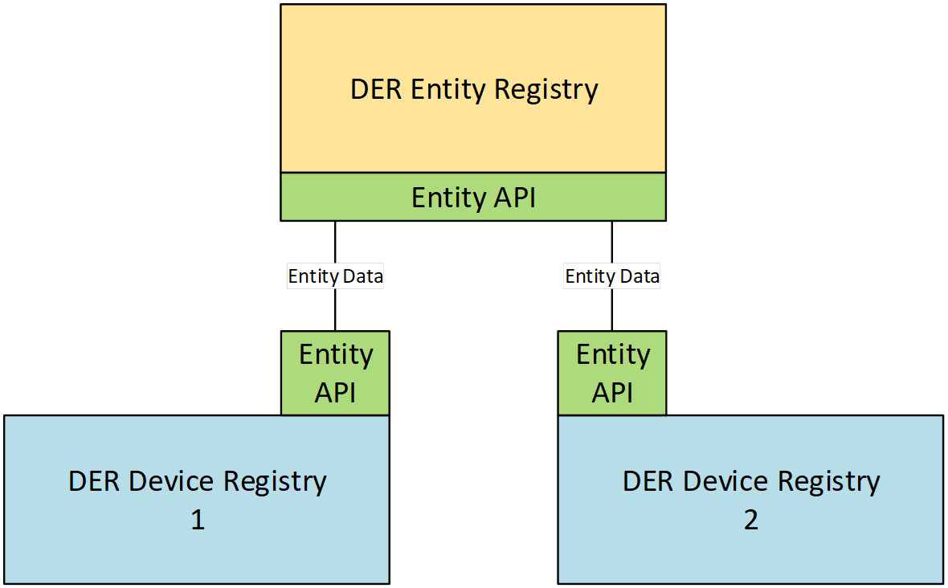

Scott Coe, Ph.D.
GRIDOPTIMIZE
Subscribe to “Optimize the Grid” on Substack

This message may contain confidential and/or privileged information. If you are not the intended recipient or authorized to receive this for the intended recipient, you must not use, copy, disclose or take any action based on this message or any information herein. If you have received this message in error, please advise the sender immediately by sending a reply email and delete this message. Thank you for your cooperation.

