Secure, Equitable Access to DER and Aggregation Data Through a Standardized Framework for DER Information Registries
Concept Paper
I. Introduction
In April 2025, at the direction of the NAESB Board of Directors, wholesale and retail electric participants initiated a joint effort to consider the development of business practice standards to support the integration of distributed energy resource (DER) and DER aggregation registries by the industry. The work is being addressed jointly by the WEQ and RMQ Business Practices Subcommittees (BPS) and is reflected on the current annual plans as 2026 WEQ Annual Plan Item 5.a / 2026 RMQ Annual Plan Item 2.a.
Over the course of thirteen meetings held between April 2025 and February 2026, participants have identified coordination challenges and gaps in the availability, consistency, and content of DER and aggregation information which has led the subcommittees to explore areas where standardization would be of greatest benefit. Informed by perspectives shared by meeting participants as well as NERC guidance and recommendations for collaborative DER information sharing, the subcommittees have found that centralized information databases, designed to be interoperable with existing industry tools and processes, could help address some of the identified issues.
The proposed conceptual approach is based on meeting discussions and input from a variety of entities representing different wholesale and retail electric market interests, including utilities, grid operators, technology service providers, and NERC staff. As described in more detail below, the subcommittees are proposing a two-part solution to:
- Create a centralized DER Entity Registry to support mutual authentication of parties
- Develop NAESB Business Practice Standards to facilitate interoperability between existing and future DER and aggregation registries and other data tools.
The subcommittees are seeking informal feedback from industry to help gauge support for moving forward and inform decisions regarding standards development and the creation of a DER Entity Registry. This Concept Paper describes the considerations that resulted from the joint discussions of the WEQ and RMQ BPS and details the proposed conceptual approach. The intent is to provide information that can be used to respond to the questions at the end of the paper.
Consistent with the NAESB process, any subsequently developed recommendation for new or revised NAESB Business Practice Standards will be voted on by WEQ and RMQ BPS participants and distributed for a formal industry comment period before being considered by the Executive Committees.
II. Problem Statement
Both reliable grid operations and effective utilization of DERs are dependent upon relevant electric industry participants having secure, consistent access to accurate DER information. However, large gaps exist in the availability of DER information critical for establishing situational awareness and carrying out necessary grid functions. Further, wide variances in the quality, content and formatting of DER data are impacting the ability of electric industry participants to efficiently collect, validate, and synthesize DER information. While manual processes exist to map disparate data between incompatible systems, the large number of DERs and quantity of data makes analysis time consuming and inefficient.
As recognized by NERC, a lack of visibility related to the quantity, location, and characteristics of DERs is driving increased variability and uncertainty for bulk power system planning and operations. Access to this same information is needed to help identify and mitigate cybersecurity risks and protect sensitive data. The data necessary to enhance DER visibility and increase situational awareness is owned or controlled by a variety of industry participants, each with their own software systems or databases. With over 3,000 distribution providers, multiple RTOs/ISOs and bulk electric grid operators, hundreds of aggregators, thousands of regulatory and permitting groups, and millions of DERs, developing customized solutions to interface with proprietary systems has significant cost implications for industry. Effective and efficient cross-market coordination and collaboration is needed to provide relevant stakeholders with fair and equal access to accurate DER information in a reliable manner.
III. Considerations of the WEQ and RMQ Business Practices Subcommittees
The WEQ and RMQ BPS initiated the effort by reviewing the various existing tools and processes used to facilitate DER data collection. Presentations and information provided by representatives from MISO, CAISO, New York ISO, Evergy, and Collaborative Utility Solutions gave insight into coordination challenges and information availability gaps and led to exploration of how standardization could help address issues identified by the subcommittees. Further discussions and subsequently developed use cases, based on NERC guidance and additional participant perspective, led to a general consensus that centralized registries, supported by a standardized framework and designed to be interoperable with existing industry tools and processes would establish mechanisms to reliably access and validate DER information that could best address some of the issues identified by the subcommittees. After evaluating possible paths for establishing such registries, it was determined that a two-part approach would be best to meet industry needs and accommodate existing structures: the creation of a centralized DER Entity Registry and development of NAESB Business Practice Standards that provide a framework to facilitate interoperability.
As identified by NERC and demonstrated by the implementation of DER registries in other countries, registries establish trusted sources to access and validate data through the creation of centralized system records and have broad applicability for the electric industry. Although stakeholders have differing operational needs, there are some common, widely used datasets, such as static operational characteristics of DERs and device type, manufacturer, ownership, and location information. This data supports a number of commercial and operational functions, including (1) DER registration and aggregation processes, (2) scheduling and operations, (3) performance validation and settlements, (4) change management, and (5) regulatory compliance and reporting efforts, including FERC Order No. 2222 and the implementation of NERC Reliability Standards developed in response to FERC Order No. 901. Standardization would improve data comparability and could streamline associated industry processes.
IV. Conceptual Approach for Proposed Two-Part Solution
The intent of the proposed two-part solution is to establish industry mechanisms and supporting NAESB Business Practice Standards that can promote broader cross-market coordination and better facilitate access to the DER and aggregation information that may enhance visibility of these resources, increase situational awareness, and assist in industry implementation of state and federal regulatory requirements. The creation of a DER Entity Registry will establish a centralized database for the registration of entities responsible for providing and requiring access to information maintained in industry developed DER registries. Additionally, the development of new NAESB Business Practice Standards will define the necessary processes and technical requirements to facilitate interoperability between existing and future DER registries and other industry data tools.
A. Creation of a Centralized DER Entity Registry
The proposed DER Entity Registry would function similar to the NAESB Electric Industry Registry (EIR). NAESB manages and operates the NAESB EIR on behalf of the wholesale electric industry as the central repository for information needed to carryout commercial scheduling and transmission management operations, including identification of relevant market participants and the interchange information necessary to populate e-Tags. The NAESB EIR supports common data formats defined by the NAESB Business Practice Standards, enabling greater interoperability, and registration is a pre-requisite to accessing certain industry tools, such as OASIS nodes and e-Tagging systems.
The DER Entity Registry will support the registration of all stakeholders that provide or require access to data housed within DER and aggregation registries and other industry data tools. Stakeholder registrations within the DER Entity Registry will define the organizational categories and functional roles necessary to mutually authenticate parties and provide a basis for establishing data access controls and cybersecurity protocols. Like the NAESB EIR, the DER Entity Registry will be supported by NAESB Business Practice Standards to define the processes and technical requirements that will facilitate entity registration and industry use as a centralized database.
The subcommittees have initially identified the following stakeholders as those that may need to be supported by specific registration categories in the DER Entity Registry:
Registration Category | Description
Aggregator | Entity that aggregates DER devices for usage by other market participants
Distribution System Provider | Entity that operates a distribution system or local transmission system
Supplier | Entity that provides competitive retail electric services to customers
Scheduling Entity | Entity responsible for submitting bids or offers and receiving schedules and awards
Bulk Power System Operator | Entity responsible for monitoring and controlling a bulk electric system
Bulk Power Reliability Coordinator | Entity responsible for the reliable operation of the bulk power system
Bulk Power Market Operator | Entity responsible for implementation of an organized market
Electric Reliability Organization | Entity certified by FERC to establish and enforce reliability standards for the bulk-power system (e.g., NERC)
Applicable Regulatory Authority | Local, state or federal regulator
The diagram below is an illustrative example of how the DER Entity Registry would interact with industry developed DER registries:
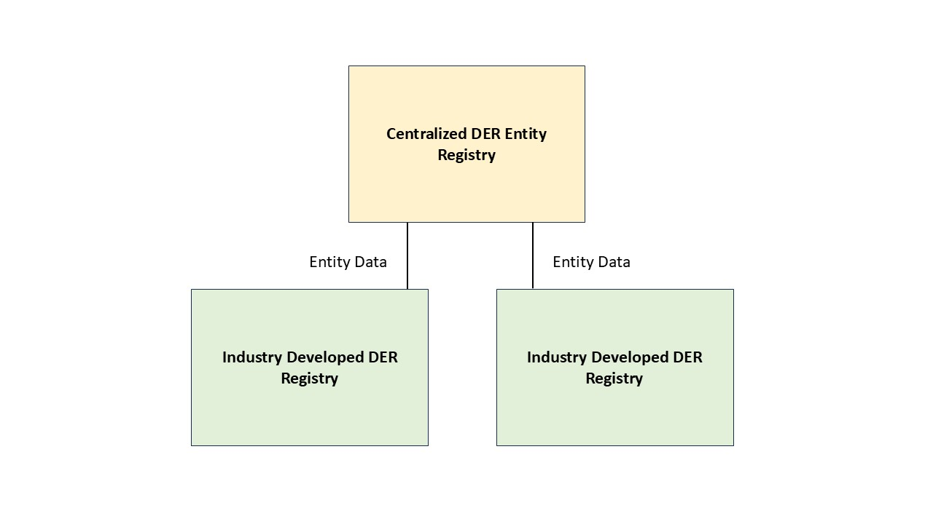
B. Development of NAESB Business Practice Standards to Facilitate Data Interoperability
Additionally, the WEQ and RMQ BPS propose the development of NAESB Business Practice Standards that will work with existing industry processes to and related industry tools to create a consistent approach for data compatibility between disparate systems that house DER and aggregation information. The standards will define processes and technical details that support consistency in data formatting, governance, and interface structures to establish a standardized framework and support interoperability. As with other NAESB Business Practice Standards, these standards can be developed to include the optionality needed by industry to maintain current customized databases, tools, and other processes tailored to specific entity, regional, or jurisdictional needs, while allowing for a consistent approach to DER and DER aggregation information sharing. NAESB also provides a process that allows for updates to its standards that ensure the industry can evolve with the introduction of new dynamic resources or changing market structures.
V. Areas of Needed Industry Feedback
To inform next steps, the subcommittees are seeking responses to the following questions:
- Would a centralized DER Entity Registry to identify and authenticate parties be beneficial? Why or why not?
- Related to the DER Entity Registry specifically:
  - Are there any additional stakeholder registration categories that need to be supported? If so, please identify and provide an explanation.
  - Are there any identified stakeholder registration categories that are not needed? If so, please identify and provide an explanation.
- Would NAESB Business Practice Standards to facilitate interoperability between existing and future DER and aggregation registries and other industry tools be beneficial? Why or why not?
- Would the creation of a DER Entity Registry and the development of NAESB Business Practice Standards to facilitate interoperability be beneficial to:
  - Support broader integration of DERs and aggregations by industry? Why or why not?
  - Help industry respond to FERC Order No. 2222, FERC Order No. 901, and/or needs for DER data? Why or why not?
- Please provide information about your organization’s role in the electric industry (e.g., market operator, distribution utility, etc.)?
- Please provide any additional information, questions, or considerations that could provide guidance to the subcommittees in determining how to proceed.

Specific material discussed by the WEQ and RMQ BPS included the NERC Transmission and Distribution Coordination Strategies White Paper that identified DER registries as one mechanism to enable uniform formatting requirements for users to aid industry’s ability to obtain needed information and facilitate collaboration between electric participants. Participants also reviewed the NERC Reducing DER Variability and Uncertainty Impacts on the Bulk Power System White Paper that recognized the “breadth of stakeholders,” outlined methods to improve DER data collection and sharing, and expanded on recommendations related to the use of DER registries and a common information model for information exchanges.

